Playwright Automation Report

Execution Summary
Script: 486883af-764c-451c-82bd-fd37e54259c2.py
Status: Execution Complete
Total Steps: 10

Captured Outputs
Step | Action | Output
1 | go_to_url | URL: http://otcsvm.otxlab.net:8090/otdsws/login?RFA=108c0e8f%2Da007%2D4165%2Dbb27%2Ddf981c095aa7%3Ahttp%3A%2F%2Fotcsvm%2Eotxlab%2Enet%3A8080%2FOTCS%2Fcs%2Eexe%3Ffunc%3Dotdsintegration%2Eredirect%26NextURL%3Dhttp%253A%252F%252Fotcsvm%252Eotxlab%252Enet%253A8080%252FOTCS%252Fcs%252Eexe&PostTicket=true&PostParams=true&ux_version=1&PreserveFragment=true&logon_style=signin-cs&logon_appname=OpenText%20Extended%20ECM%20CE%2023%2E3
2 | input_text | URL: http://otcsvm.otxlab.net:8090/otdsws/login?RFA=108c0e8f%2Da007%2D4165%2Dbb27%2Ddf981c095aa7%3Ahttp%3A%2F%2Fotcsvm%2Eotxlab%2Enet%3A8080%2FOTCS%2Fcs%2Eexe%3Ffunc%3Dotdsintegration%2Eredirect%26NextURL%3Dhttp%253A%252F%252Fotcsvm%252Eotxlab%252Enet%253A8080%252FOTCS%252Fcs%252Eexe&PostTicket=true&PostParams=true&ux_version=1&PreserveFragment=true&logon_style=signin-cs&logon_appname=OpenText%20Extended%20ECM%20CE%2023%2E3
3 | input_text | URL: http://otcsvm.otxlab.net:8090/otdsws/login?RFA=108c0e8f%2Da007%2D4165%2Dbb27%2Ddf981c095aa7%3Ahttp%3A%2F%2Fotcsvm%2Eotxlab%2Enet%3A8080%2FOTCS%2Fcs%2Eexe%3Ffunc%3Dotdsintegration%2Eredirect%26NextURL%3Dhttp%253A%252F%252Fotcsvm%252Eotxlab%252Enet%253A8080%252FOTCS%252Fcs%252Eexe&PostTicket=true&PostParams=true&ux_version=1&PreserveFragment=true&logon_style=signin-cs&logon_appname=OpenText%20Extended%20ECM%20CE%2023%2E3
4 | click_element_by_index | URL: http://otcsvm.otxlab.net:8080/OTCS/cs.exe?func=llworkspace
5 | go_to_url | URL: http://otcsvm.otxlab.net:8080/OTCS/cs.exe?func=distributedagent.AgentStatus
6 | scroll_to_text | URL: http://otcsvm.otxlab.net:8080/OTCS/cs.exe?func=distributedagent.AgentStatus&sec=0
7 | extract_content | Extracted: Distributed Agent ID Primary Last Update Status Status Description Actions DAAgent_otcsvm_2099_1 02/23/2026 10:49 PM Running: Distributed Agent ID Distributed Agent ID: Primary Primary: Last Update Last Update: Status Status: Status Description Status Description: Actions Distributed Agent ID Primary Last Update Status Status Description Actions DAAgent_otcsvm_2099_1 02/23/2026 10:49 PM Running: DAAgent_otcsvm_2099_1 Distributed Agent ID: 02/23/2026 10:49 PM Primary: Running Distribut
8 | scroll_to_text | URL: http://otcsvm.otxlab.net:8080/OTCS/cs.exe?func=distributedagent.AgentStatus&sec=0
9 | extract_content | Extracted: Distributed Agent ID Primary Last Update Status Status Description Actions DAAgent_otcsvm_2099_1 02/23/2026 10:49 PM Running: Distributed Agent ID Distributed Agent ID: Primary Primary: Last Update Last Update: Status Status: Status Description Status Description: Actions Distributed Agent ID Primary Last Update Status Status Description Actions DAAgent_otcsvm_2099_1 02/23/2026 10:49 PM Running: DAAgent_otcsvm_2099_1 Distributed Agent ID: 02/23/2026 10:49 PM Primary: Running Distribut
10 | done | URL: http://otcsvm.otxlab.net:8080/OTCS/cs.exe?func=distributedagent.AgentStatus&sec=0

Automation Steps

Step 1: go_to_url
Action | go_to_url
Captured Output | URL: http://otcsvm.otxlab.net:8090/otdsws/login?RFA=108c0e8f%2Da007%2D4165%2Dbb27%2Ddf981c095aa7%3Ahttp%3A%2F%2Fotcsvm%2Eotxlab%2Enet%3A8080%2FOTCS%2Fcs%2Eexe%3Ffunc%3Dotdsintegration%2Eredirect%26NextURL%3Dhttp%253A%252F%252Fotcsvm%252Eotxlab%252Enet%253A8080%252FOTCS%252Fcs%252Eexe&PostTicket=true&PostParams=true&ux_version=1&PreserveFragment=true&logon_style=signin-cs&logon_appname=OpenText%20Extended%20ECM%20CE%2023%2E3
Screenshot:
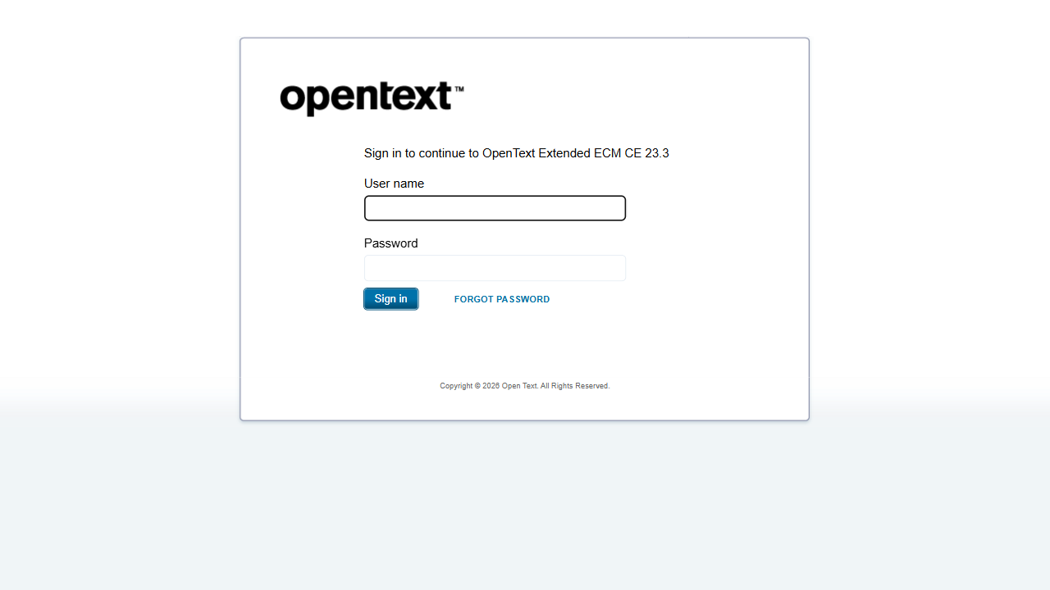

Step 2: input_text
Action | input_text
Captured Output | URL: http://otcsvm.otxlab.net:8090/otdsws/login?RFA=108c0e8f%2Da007%2D4165%2Dbb27%2Ddf981c095aa7%3Ahttp%3A%2F%2Fotcsvm%2Eotxlab%2Enet%3A8080%2FOTCS%2Fcs%2Eexe%3Ffunc%3Dotdsintegration%2Eredirect%26NextURL%3Dhttp%253A%252F%252Fotcsvm%252Eotxlab%252Enet%253A8080%252FOTCS%252Fcs%252Eexe&PostTicket=true&PostParams=true&ux_version=1&PreserveFragment=true&logon_style=signin-cs&logon_appname=OpenText%20Extended%20ECM%20CE%2023%2E3
Screenshot:
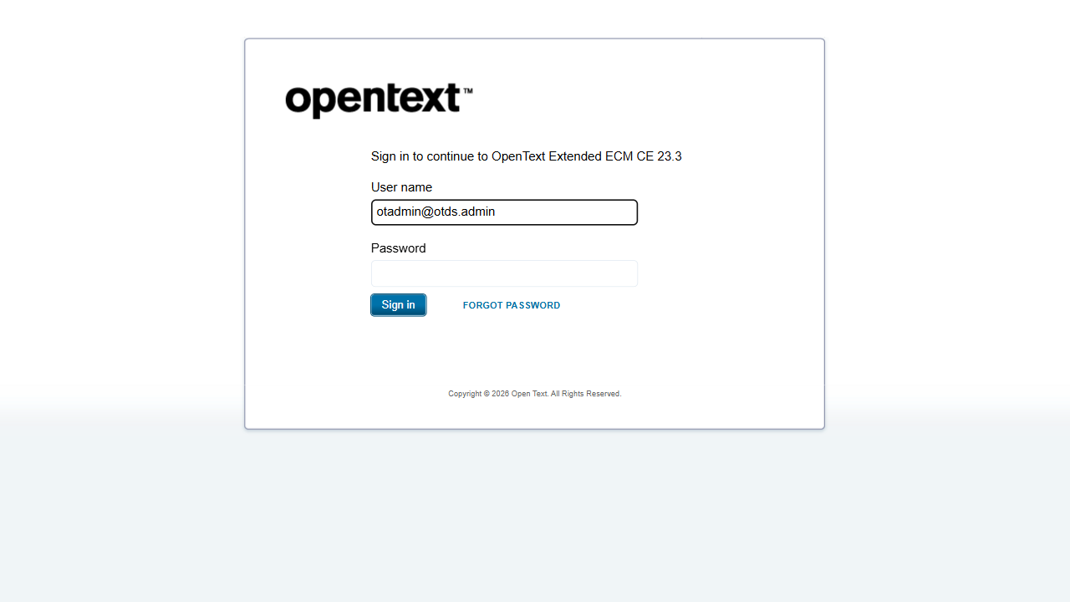

Step 3: input_text
Action | input_text
Captured Output | URL: http://otcsvm.otxlab.net:8090/otdsws/login?RFA=108c0e8f%2Da007%2D4165%2Dbb27%2Ddf981c095aa7%3Ahttp%3A%2F%2Fotcsvm%2Eotxlab%2Enet%3A8080%2FOTCS%2Fcs%2Eexe%3Ffunc%3Dotdsintegration%2Eredirect%26NextURL%3Dhttp%253A%252F%252Fotcsvm%252Eotxlab%252Enet%253A8080%252FOTCS%252Fcs%252Eexe&PostTicket=true&PostParams=true&ux_version=1&PreserveFragment=true&logon_style=signin-cs&logon_appname=OpenText%20Extended%20ECM%20CE%2023%2E3
Screenshot:
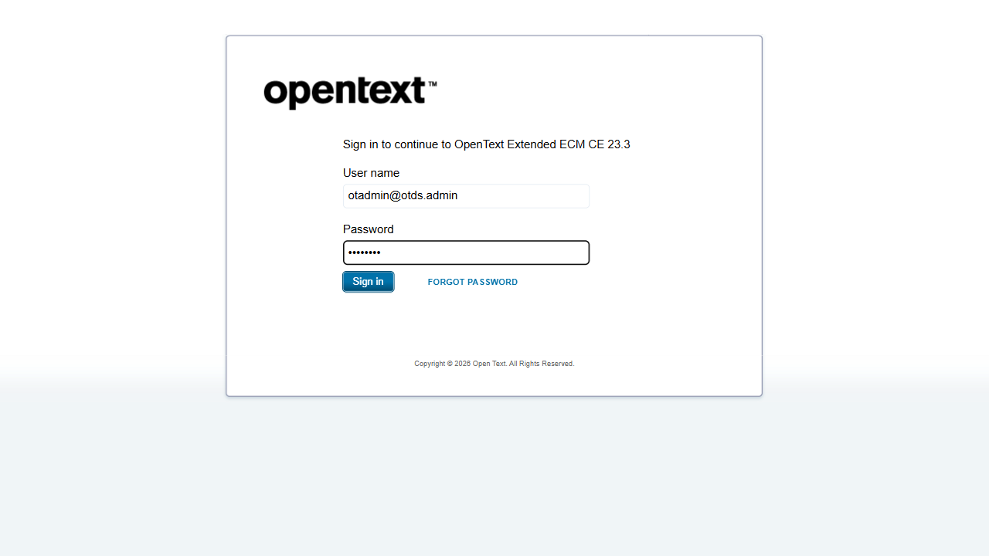

Step 4: click_element_by_index
Action | click_element_by_index
Captured Output | URL: http://otcsvm.otxlab.net:8080/OTCS/cs.exe?func=llworkspace
Screenshot:
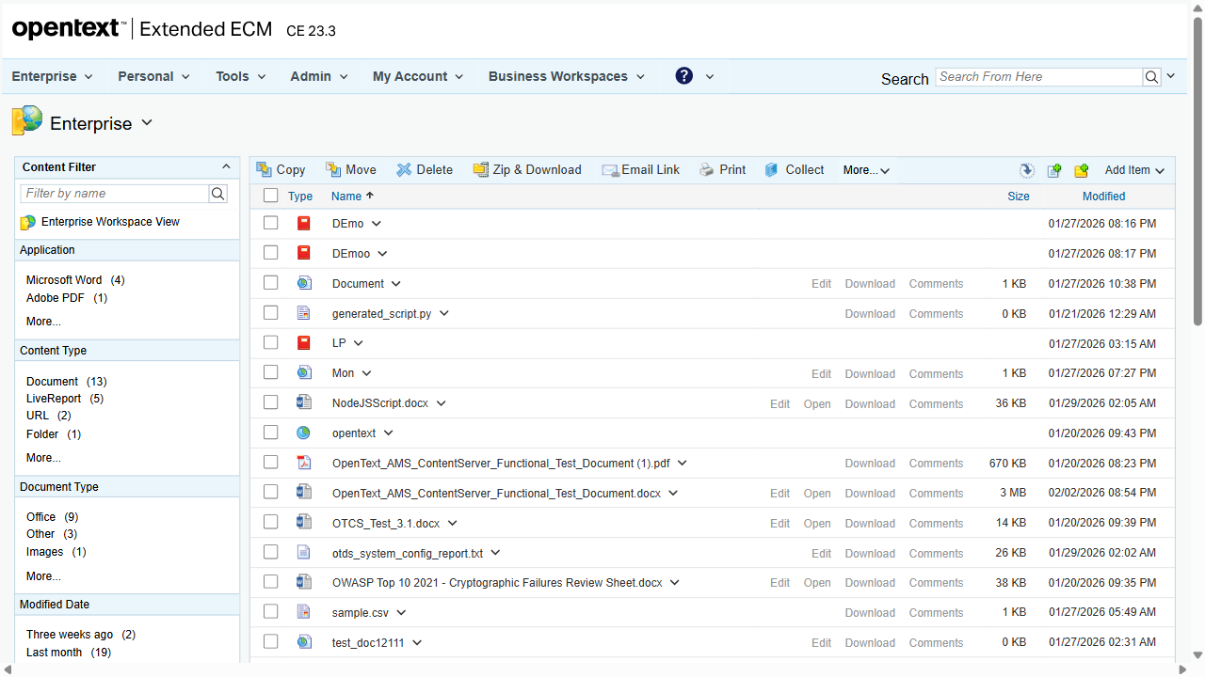

Step 5: go_to_url
Action | go_to_url
Captured Output | URL: http://otcsvm.otxlab.net:8080/OTCS/cs.exe?func=distributedagent.AgentStatus
Screenshot:
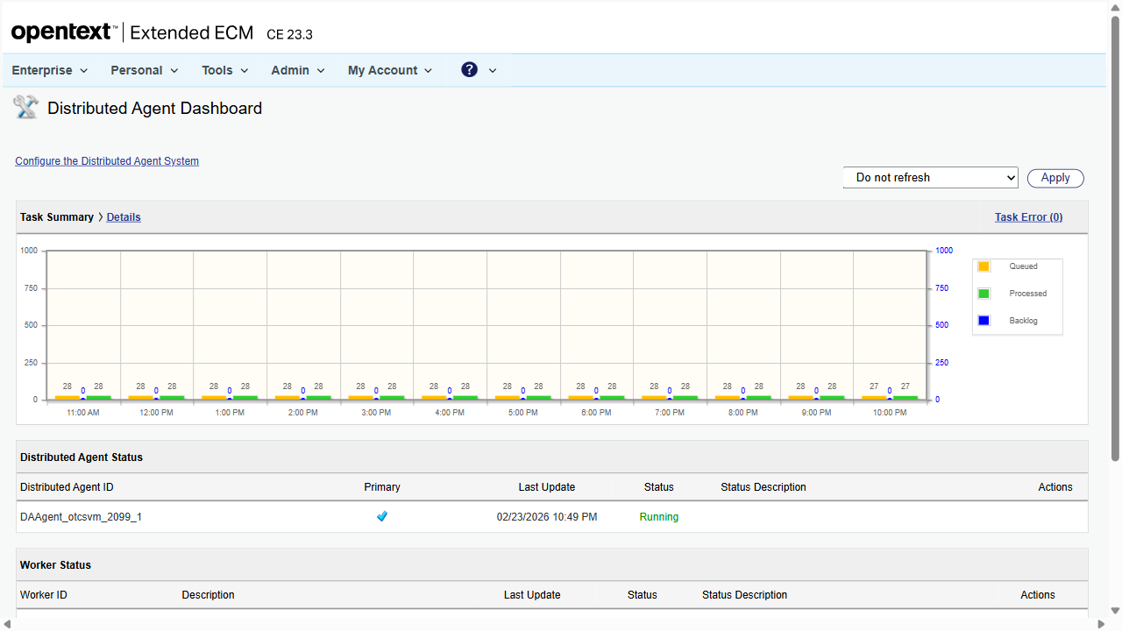

Step 6: scroll_to_text
Action | scroll_to_text
Captured Output | URL: http://otcsvm.otxlab.net:8080/OTCS/cs.exe?func=distributedagent.AgentStatus&sec=0
Screenshot:
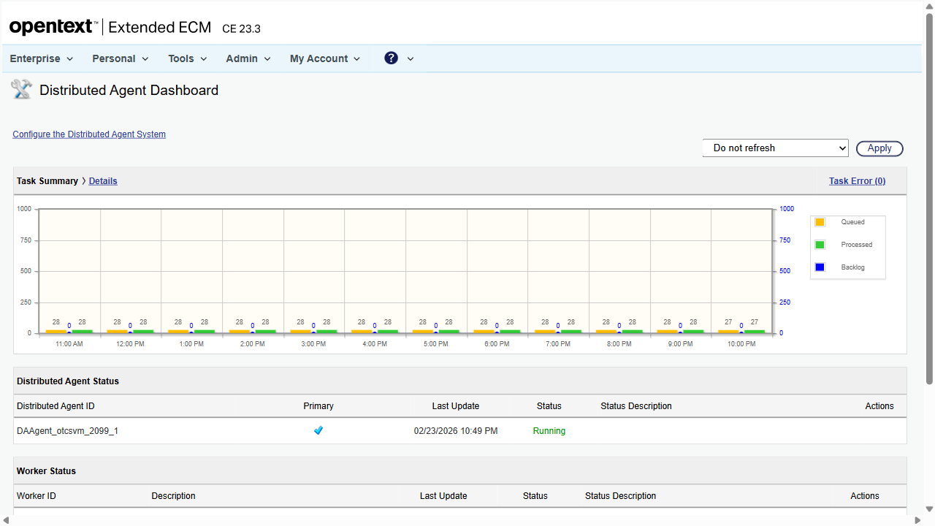

Step 7: extract_content
Action | extract_content
Captured Output | Extracted: Distributed Agent ID Primary Last Update Status Status Description Actions DAAgent_otcsvm_2099_1 02/23/2026 10:49 PM Running: Distributed Agent ID Distributed Agent ID: Primary Primary: Last Update Last Update: Status Status: Status Description Status Description: Actions Distributed Agent ID Primary Last Update Status Status Description Actions DAAgent_otcsvm_2099_1 02/23/2026 10:49 PM Running: DAAgent_otcsvm_2099_1 Distributed Agent ID: 02/23/2026 10:49 PM Primary: Running Distributed Agent ID
Screenshot:


Step 8: scroll_to_text
Action | scroll_to_text
Captured Output | URL: http://otcsvm.otxlab.net:8080/OTCS/cs.exe?func=distributedagent.AgentStatus&sec=0
Screenshot:


Step 9: extract_content
Action | extract_content
Captured Output | Extracted: Distributed Agent ID Primary Last Update Status Status Description Actions DAAgent_otcsvm_2099_1 02/23/2026 10:49 PM Running: Distributed Agent ID Distributed Agent ID: Primary Primary: Last Update Last Update: Status Status: Status Description Status Description: Actions Distributed Agent ID Primary Last Update Status Status Description Actions DAAgent_otcsvm_2099_1 02/23/2026 10:49 PM Running: DAAgent_otcsvm_2099_1 Distributed Agent ID: 02/23/2026 10:49 PM Primary: Running Distributed Agent ID
Screenshot:


Step 10: done
Action | done
Captured Output | URL: http://otcsvm.otxlab.net:8080/OTCS/cs.exe?func=distributedagent.AgentStatus&sec=0
Screenshot:


